# ADCtest Quick Start Manual

Version 1.02

**Änderungshistorie**

|  |  |  |  |
| --- | --- | --- | --- |
| Bearbeiter | Version | Datum | Beschreibung der Änderung |
| Thomas Buck | 1.00 | 01.04.2019 | Erste Version |
| Heiko Lauer | 1.01 | 03.04.2019 | Minor changes |
| Thomas Buck | 1.02 | 15.04.2019 | Chapter tilt compensation |

Inhaltsverzeichnis

ADCtest Quick Start Manual 1

1. Calibration 4

2. Tilt compensation 7

## Calibration

1. First set the load cell to welmec mode (switch on digital load cell opened)
2. Switch on scale
3. Close all bizerba applications  
   - Open Terminal: Press left mouse button on desktop and choose “Terminal”  
   - go to directory with “cd /opt/bizerba/posscale/linux_x86”  
   - start script “./stop.sh”
4. Now set the load cell in calibration mode (switch on digital load cell closed)
5. Start adctest.x application  
   - go to directory with “cd /opt/bizerba/adctest”  
   - start application with “./adctest.x”
6. Open connection to the load cell  
   - select OpenAdc [“o”]  
   - Interface is usb [“0”]  
   - if the connection is successful the Handle is != Zero  
   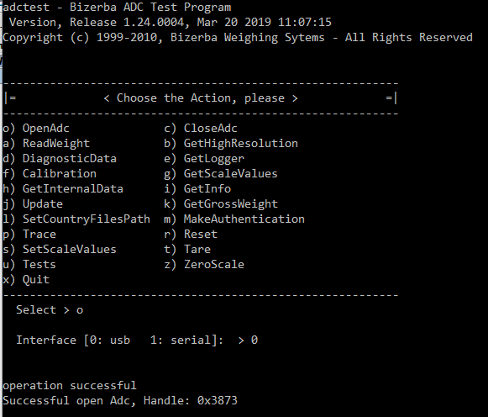
7. Start calibration  
   - select Calibration [“f”]  
   - calibrate without tilt compensation [“0”]  
   - no country (use the installed country)  
   - not change load capacity  
   - ssp directory must be also empty  
   - no scale model  
   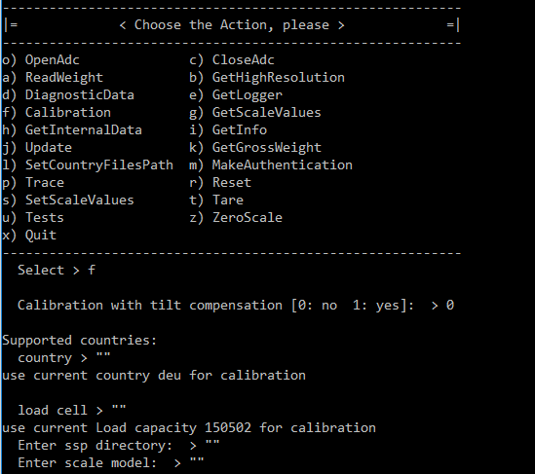
8. Execution  
   - unload scale  
   - load scale with max  
   - unload scale  
   - load scale with max  
   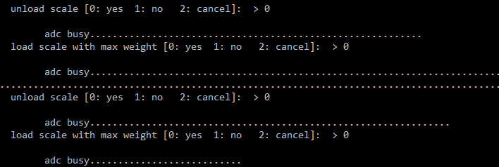
9. Set production site to local [“0”]  
   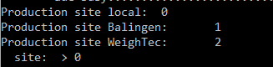
10. Set g-Factor to zero  
    
11. Calibration finish  
    
12. Set load cell to welmec mode (switch on digital load cell opened)
13. Now reboot device
14. After reboot check if tilt compensation is still active  
    - select tab “Current”  
    - check Tilt value  
    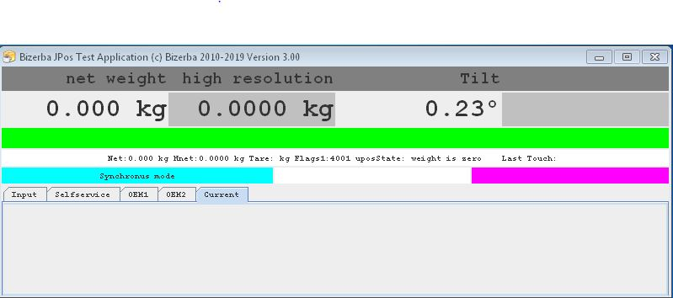

## Tilt compensation

1. It is not possible to change the tilt compensation state in welmec mode, so first switch the scale into calibration mode (see chapter Calibration point a)-d) )
2. Start adctest.x application  
   - go to directory with “cd /opt/bizerba/adctest”  
   - start application with “./adctest.x”
3. Open connection to the load cell  
   - select OpenAdc [“o”]  
   - Interface is usb [“0”]  
   - if the connection is successful the Handle is != Zero  
   
4. Enable/Disable tilt compensation  
   - select SetScaleValues [“s”]  
   - select Set tilt compensation [“4”]  
   - to enable tilt compensation input “1”, to disable tilt compensation input “0”  
   - tilt corner load correction must set to disable [“0”]  
   - weight dependent tilt angle must set to disable [“0”]  
   - limit angle must be set to 286  
     
   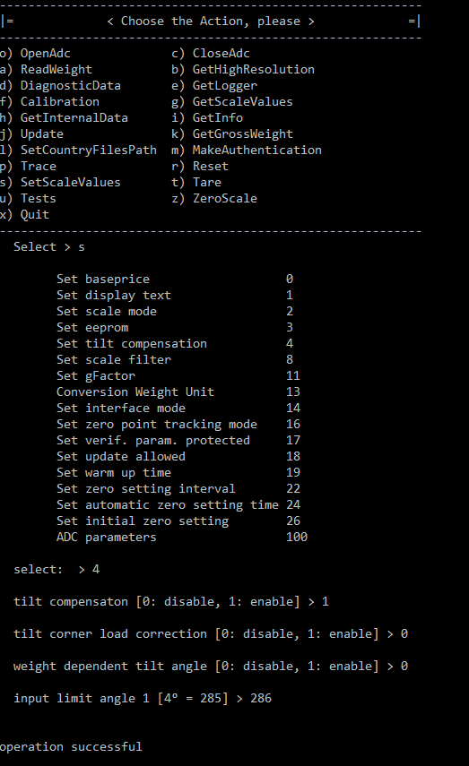
5. Close application with Quit [“x”]
6. Set load cell to welmec mode (switch on digital load cell opened)
7. Now reboot device
8. If you have enabled tilt compensation check after reboot if tilt compensation is active  
   - select tab “Current”  
   - check Tilt value

